Lab 07. Implementation of 4 bit array multiplier using Verilog HDL

Objectives.

The design and implementation for 4-bit binary multiplier

Verify correctness by comparing the output against expected results for various input combinations.

Implement smaller modules for partial product generation and addition.

# Introduction

A 4-bit array multiplier is a digital circuit or component designed to multiply two 4-bit binary numbers. Each of the binary numbers is treated as an array of 4 bits, and the multiplication is carried out using a systematic arrangement of logic gates. The array multiplier performs a series of partial products and adds them to obtain the final result of the multiplication.

The gate level diagram of the 4 bit array multiplier was obtained as follows : - (The unconnected inputs are the combinations of the input bits ANDed in pairs. The exact combinations at each adder box can be found out from the Verilog code)

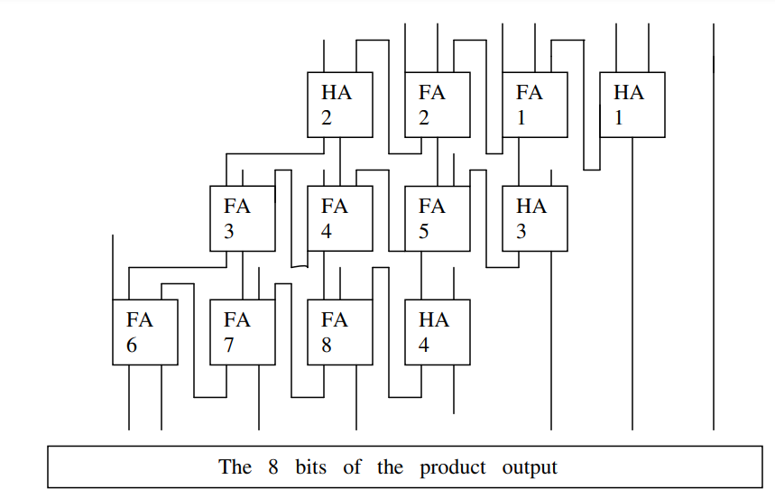

module HA(sout,cout,a,b); output sout,cout;

input a,b;

assign sout=a^b; assign cout=(a&b); endmodule

module FA(sout,cout,a,b,cin);

output sout,cout; input a,b,cin;

assign sout=(a^b^cin);

assign cout=((a&b)|(a&cin)|(b&cin)); endmodule

module multiply4bits(product,inp1,inp2); output [7:0]product;

input [3:0]inp1; input [3:0]inp2;

assign product[0]=(inp1[0]&inp2[0]);

wire x1,x2,x3,x4,x5,x6,x7,x8,x9,x10,x11,x12,x13,x14,x15,x16,x17; HA HA1(product[1],x1,(inp1[1]&inp2[0]),(inp1[0]&inp2[1]));

FA FA1(x2,x3,inp1[1]&inp2[1],(inp1[0]&inp2[2]),x1);

FA FA2(x4,x5,(inp1[1]&inp2[2]),(inp1[0]&inp2[3]),x3); HA HA2(x6,x7,(inp1[1]&inp2[3]),x5);

HA HA3(product[2],x15,x2,(inp1[2]&inp2[0]));

FA FA5(x14,x16,x4,(inp1[2]&inp2[1]),x15);

FA FA4(x13,x17,x6,(inp1[2]&inp2[2]),x16);

FA FA3(x9,x8,x7,(inp1[2]&inp2[3]),x17);

HA HA4(product[3],x12,x14,(inp1[3]&inp2[0]));

FA FA8(product[4],x11,x13,(inp1[3]&inp2[1]),x12);

FA FA7(product[5],x10,x9,(inp1[3]&inp2[2]),x11); FA

FA6(product[6],product[7],x8,(inp1[3]&inp2[3]),x10); Endmodule

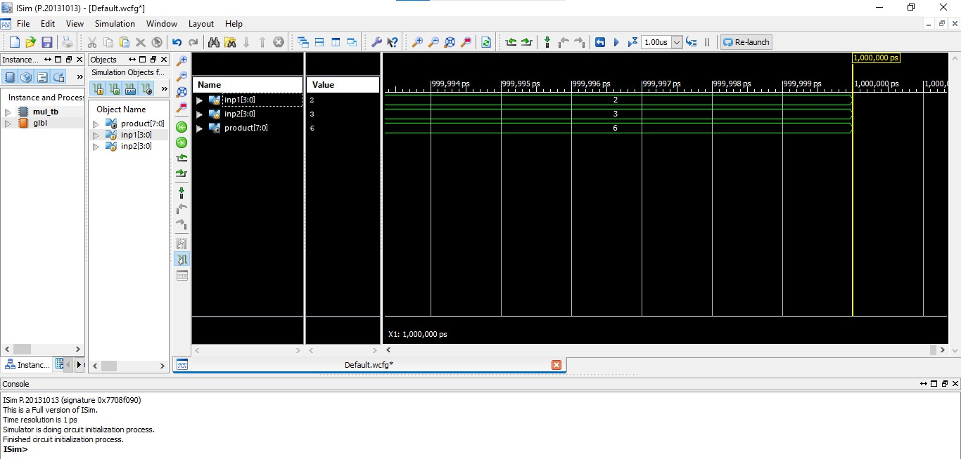

# Task

Implement the following Multiplier using Verilog.

